

**Artificial Intelligence and Data Science Department.**

OOPM / Odd Sem 2021-22 / Experiment 4.

YASH SARANG.

47 / D6AD.

EXPERIMENT - 4.

**_________________________________________________________________**

**AIM:** Write a program for a class Student,

accept the name, roll no, marks of three subjects, calculate total from the user

and display the complete information.

**_________________________________________________________________**

**THEORY:** Detail theory about Classes and objects

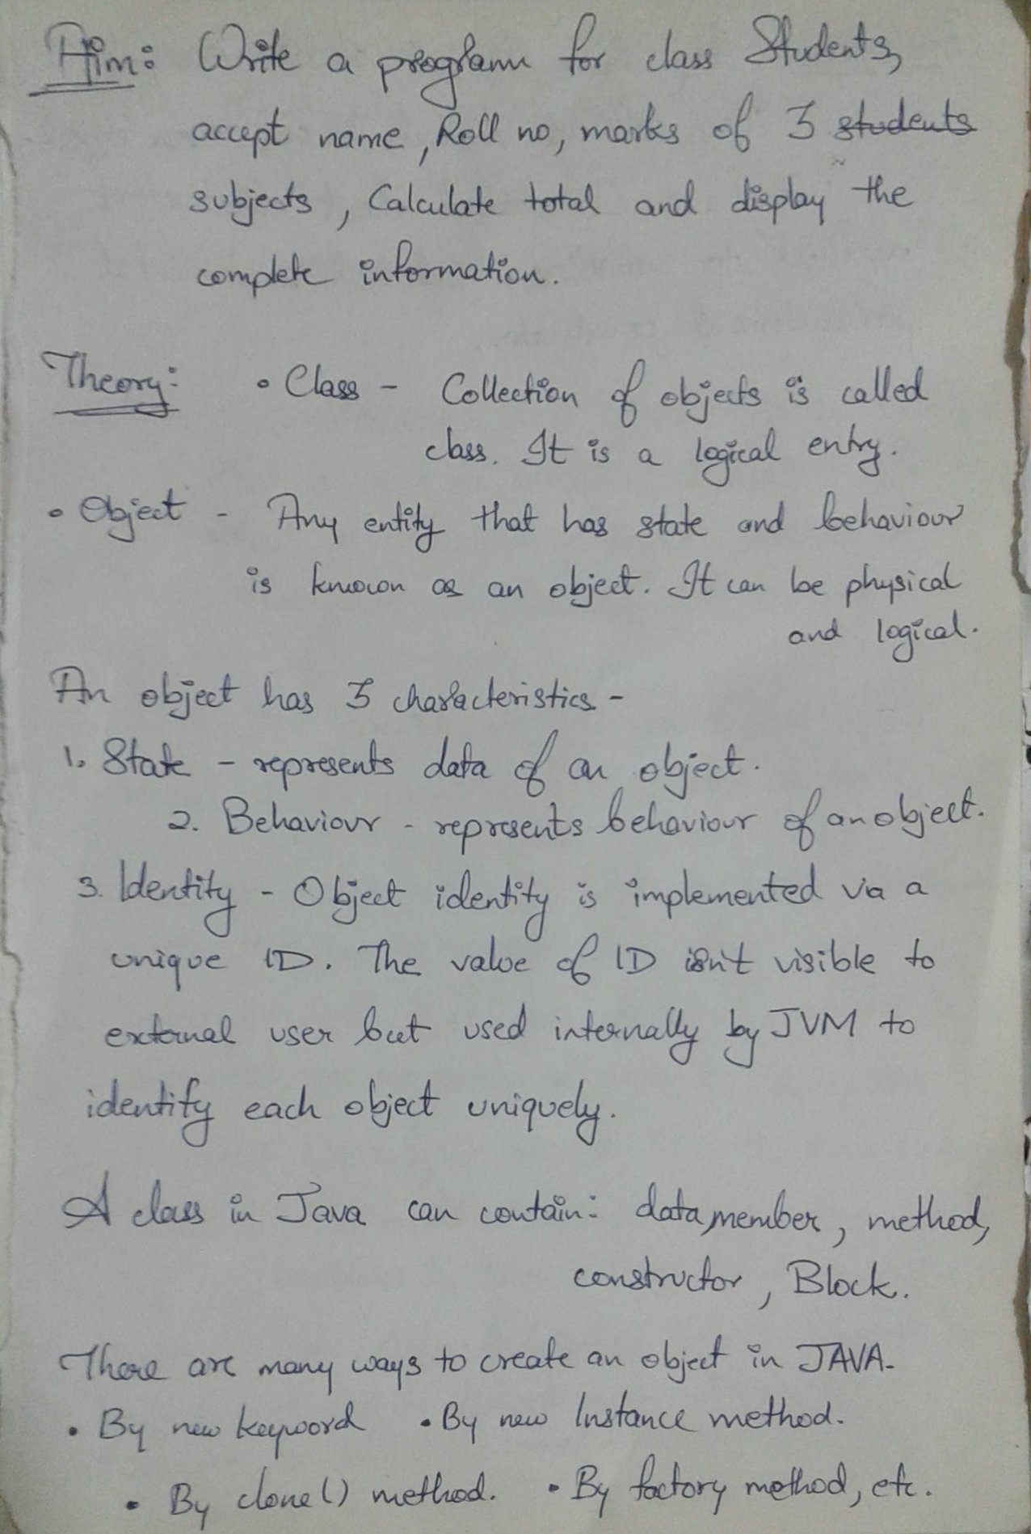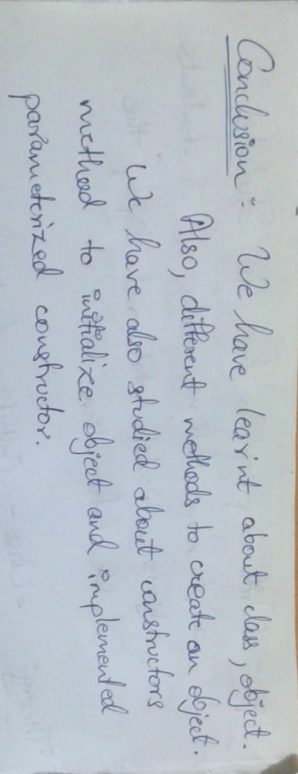

**_________________________________________________________________**

**Program:** Program for a class Student, which accepts name, roll no, marks of three subjects, calculate total from the user and displays the complete information.

import java.lang.*;

import java.util.*;

class Student

{

String name;

int rollno;

int subject1_marks;

int subject2_marks;

int subject3_marks;

int total;

void basicinfo(String n,int r)

{

name = n;

rollno = r;

}

void marks(int m1,int m2,int m3)

{

subject1_marks = m1;

subject2_marks = m2;

subject3_marks = m3;

}

void total()

{

total = subject1_marks + subject2_marks + subject3_marks;

}

void display()

{

System.out.println("The information of student is as follows:");

System.out.println("Name : " + name);

System.out.println("Roll No.: " + rollno);

System.out.println("Marks in Subject 1: " + subject1_marks);

System.out.println("Marks in Subject 2: " + subject2_marks);

System.out.println("Marks in SUbject 3: " + subject3_marks);

System.out.println("Total Marks : " + total + "/300");

}

public static void main(String[] args)

{

Student s1 = new Student();

Scanner sc = new Scanner(System.in);

System.out.print("Enter your name : ");

String a = sc.nextLine();

System.out.print("Enter your Roll No. : ");

int b = sc.nextInt();

System.out.print("Enter marks obtained in three subjects : ");

int a1 = sc.nextInt();

int a2 = sc.nextInt();

int a3 = sc.nextInt();

s1.basicinfo(a,b);

s1.marks(a1,a2,a3);

s1.total();

s1.display();

}

}

**The output of program:**



